**To enter a name, age and transition to addition GUI**

**Algorithm**

1. start
2. enter name input
3. print result
4. show name output
5. print result
6. enter number
7. print result
8. show name and age
9. process/transition to addition promt
10. enter number a
11. enter number b
12. print result of a and b

**Flowchart**

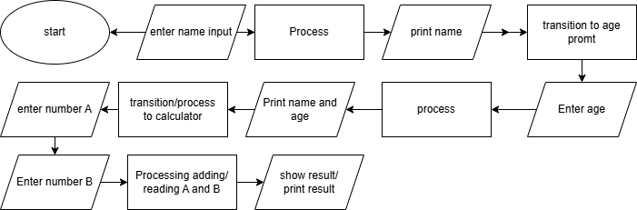

**Program**

import javax.swing.JOptionPane;

import javax.swing.*;

import java.awt.*;

import java.awt.event.*;

public class gui {

    public static void main(String[] args) {

        String name = JOptionPane.showInputDialog("Enter Your Name: ");

        JOptionPane.showMessageDialog(null, "hello " + name);

        int age = Integer.parseInt(JOptionPane.showInputDialog("Enter Your age"));

        JOptionPane.showMessageDialog(null, "hello " + name + " you are " + age + " years old");

        JFrame frame = new JFrame("the hell is this???");

        frame.setSize(500,400);

        frame.setVisible(true);

        frame.setDefaultCloseOperation(JFrame.EXIT_ON_CLOSE);

        frame.setLayout(null);

        JLabel l1 = new JLabel("Enter the number: ");

        l1 .setBounds(100, 100, 100, 20);

        frame.add(l1);

        JTextField t1 = new JTextField(10);

        t1.setBounds(201, 100, 100, 20);

        frame.add(t1);

        JLabel l2 = new JLabel("Enter the number: ");

        l2 .setBounds(100, 150, 100, 20);

        frame.add(l2);

        JTextField t2 = new JTextField(10);

        t2.setBounds(201, 150, 100, 20);

        frame.add(t2);

        JButton btn = new JButton("Add");

        btn.setBounds(100, 200, 100, 20);

        frame.add(btn);

        JLabel result = new JLabel("Result: ");

        result.setBounds(100, 250, 100, 20);

        result.setForeground(Color.BLACK);

        frame.add(result);

        btn.addActionListener(new ActionListener(){

            public void actionPerformed(ActionEvent ae){

                int n1 = Integer.parseInt(t1.getText());

                int n2 = Integer.parseInt(t2.getText());

                int sum = n1 + n2;

                result.setText("Result: " + sum);

            }

        });

    }

}